**Task 1: Develop a java program for calculating the total electricity bill when a user enters the number of units consumed. For the calculations of the total bill consider the following tariff:**

**Number of Units Price PER unit in Rupees**

Initial 50 units 10

50-100 15

101-200 20

201-300 25

301-onwards 30

import java.util.Scanner;

public class Task1Bill {

public static void main(String[] args) {

int numberOfUnits, totalBill;

System.***out***.print("Enter number of units consumed: ");

numberOfUnits = new Scanner(System.***in***).nextInt();

if (numberOfUnits < 50)

totalBill = numberOfUnits * 10;

else if (numberOfUnits>= 50 && numberOfUnits <= 100)

totalBill = numberOfUnits * 15;

else if (numberOfUnits>= 101 && numberOfUnits <= 200)

totalBill = numberOfUnits * 20;

else if (numberOfUnits>= 201 && numberOfUnits <= 300)

totalBill = numberOfUnits * 25;

else

totalBill = numberOfUnits * 30;

System.***out***.println("Sir your Total Bill is: "+totalBill+" Rs.");

}

}

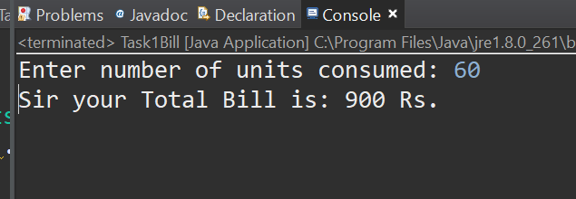

**Task 2: Develop java code that prints following.**

*

* * *

* * * * *

* * * * * * *

* * * * * * * * *

1

2 3 2

3 4 5 4 3

4 5 6 7 6 5 4

5 6 7 8 9 8 7 6 5

*****

****

***

**

*

public class Task2Patterns {

public static void main(String[] args) {

int n = 5;

// pattern#1

for (int i = 0; i < n; i++) {

for (int j = 0; j <= 2*n-1; j++) {

if (j>=(n-i) && j<=(n+i))

System.***out***.print("*");

else

System.***out***.print(" ");

}

System.***out***.println();

}

System.***out***.println();

int count=1; //variable to help in printing pattern

// Pattern#2

for (int i = 0; i < n; i++) {

for (int j = 0; j <=2*n-1; j++) {

if (j >= (n - i) && j<=n){

System.***out***.print(" "+(i+count));

count++;

if (j==n) { //in last iteration it is also incremented

count--; //that we don't want

}

}

else if (j <= (n + i) && j>n){

System.***out***.print(" "+(i+count-1));

count--;

}

else

System.***out***.print(" ");

}

count=1;

System.***out***.println();

}

System.***out***.println();

///Pattern#3

for (int i = n; i >=0; i--) {

for (int j = i; j >0; j--) {

System.***out***.print("*");

}

System.***out***.println();

}

}

}

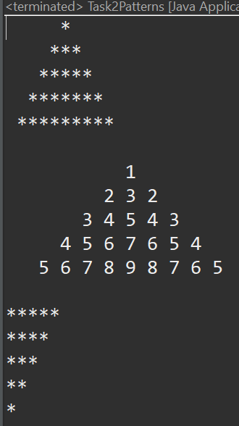

**Task 3: Write a java program that takes the table, starting and ending point of the table and prints the output in the following way:**

**5x5 = 25**

**5x6 = 30**

**5x7 = 35**

**5x8 = 40**

**5x9 = 45**

**5x10 = 50**

import java.util.Scanner;

public class Task3Table {

public static void main(String[] args) {

int startPoint,endPoint;

System.***out***.print("Enter starting point of table: ");

startPoint=new Scanner(System.***in***).nextInt();

System.***out***.print("Enter ending point of table: ");

endPoint=new Scanner(System.***in***).nextInt();

for (int i = startPoint; i <= endPoint; i++) {

System.***out***.print("\n"+5+"x"+i+" = "+(5*i));

}

}

}

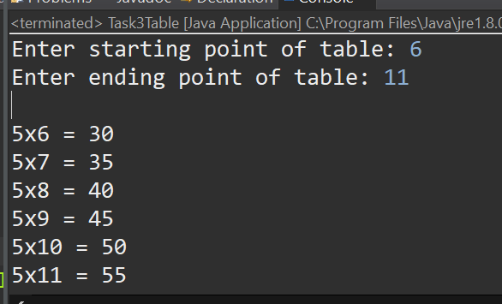

**Task 4: Write a program to display first n terms of a Fibonacci series.**

**Sample Output:**

**Input number of terms to display : 10**

**Fibonacci Series: 1 1 2 3 5 8 13 21 34**

import java.util.Scanner;

public class Task4Fabonocci {

public static void main(String[] args) {

int previousterm = 0, nextTerm = 1, sum = 0;

int numberOfTerms;

System.***out***.print("Enter number of terms in series: ");

numberOfTerms = new Scanner(System.***in***).nextInt();

for (int i = 0; i < numberOfTerms; i++) {

System.***out***.print(nextTerm+" ");

sum=previousterm+nextTerm;

previousterm=nextTerm;

nextTerm=sum;

}

}

}

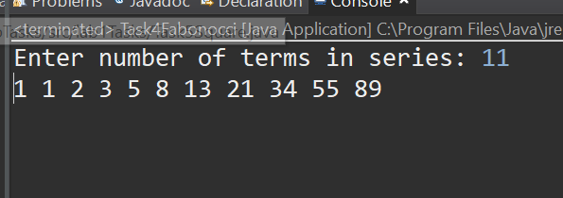

**Task 5: Write a program that calculates the square of a number provided by the user without using any built-in function or the * operator.**

import java.util.Scanner;

public class Task5Square {

public static void main(String[] args) {

int number,squareOfNumber=0;

System.***out***.print("Enter a number to find its square: ");

number= new Scanner(System.***in***).nextInt();

if (number<0) //if number is negative

number=-number;

for (int i = 0; i < number; i++) {

squareOfNumber+=number;

}

System.***out***.println("("+number+")^2 = "+squareOfNumber);

}

}

}